LABORATORY OBSERVATION
Course: Full Stack Web Development
Course Code: 23CM4121
Experiment No.: 1
Student Name: P. Santosh Kumar
Roll No.: A24126552082
Date: 30-08-2026
TITLE
Develop a College Information Portal Using HTML and HTML5

AIM
To understand and implement the fundamental building blocks of HTML and HTML5 for creating structured web pages.

OBJECTIVES
- Create a valid HTML5 document and structure a college information webpage.
- Use headings, paragraphs, text formatting, hyperlinks, lists, tables, and images.
- Design a student registration form using common HTML form controls.
- Apply semantic HTML5 elements and modern input types.
- Embed audio, video, and an iframe in a webpage.

CONCEPTS COVERED
- HTML5 Document Structure
- Basic HTML Tags
- Text Formatting
- Hyperlinks
- Lists
- Tables
- Images
- Frames / Iframes
- Forms
- HTML5 Semantic Elements
- HTML5 Input Types
- Audio & Video
TASK DESCRIPTION
Part A: Basic HTML – Create a valid HTML5 document, display college information using headings and paragraphs, apply text formatting, create ordered and unordered lists, and add hyperlinks to the college website and Google.
Part B: Tables and Images – Create a student details table with Roll No, Name, Branch, and Email, and insert the college logo and a relevant image with alternate text.
Part C: Forms – Design a student registration form containing Name, Email, Password, Gender, Hobbies, Branch, Comments, Submit, and Reset controls.
Part D: HTML5 Features – Use semantic elements, embed audio and video, and use HTML5 input types such as Email, Date, Number, Color, and Range.
ALGORITHM / PROCEDURE
1. Create an HTML5 document using the DOCTYPE declaration and html, head, and body elements.
2. Add the page title and college header information.
3. Create navigation links using the nav element and anchor tags.
4. Add college information, formatted text, ordered lists, and unordered lists.
5. Create a student details table and insert the college logo with alternate text.
6. Design the student registration form using text, email, password, radio, checkbox, select, textarea, submit, and reset controls.
7. Add HTML5 controls for date, number, color, and range inputs.
8. Add semantic header, nav, main, section, article, and footer elements.
9. Embed audio, video, and iframe content.
10. Open the HTML file in a browser and verify the displayed webpage.

PROGRAM / SOURCE CODE
The following pages contain the submitted HTML source code screenshots.
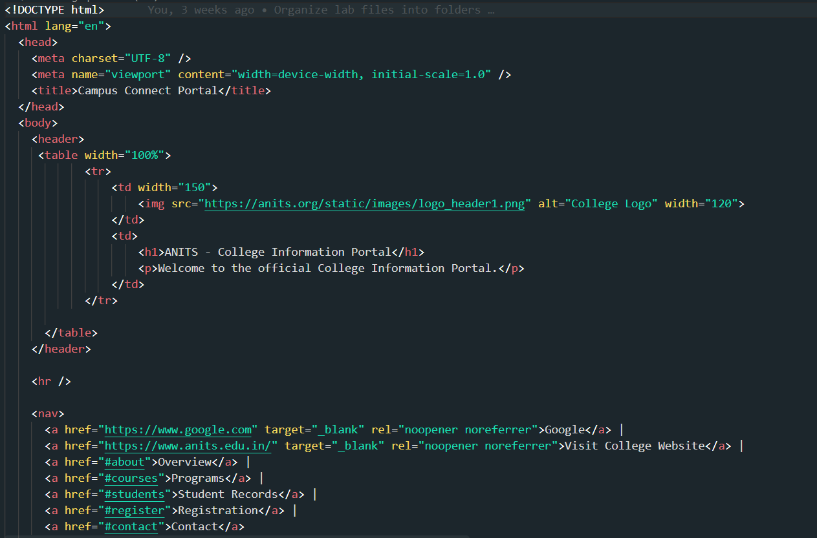
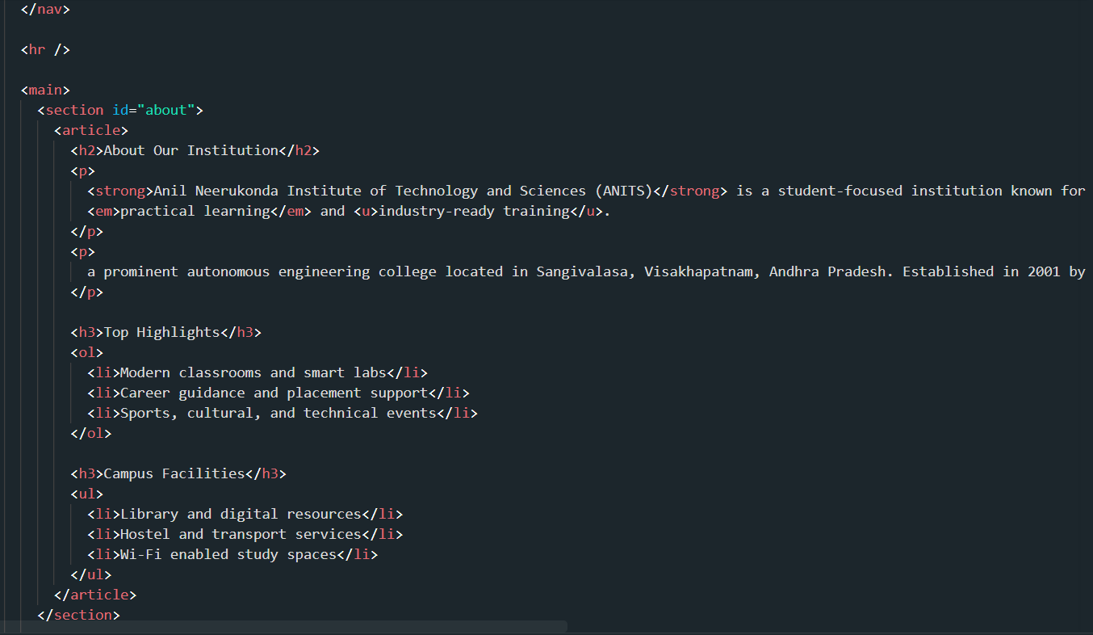

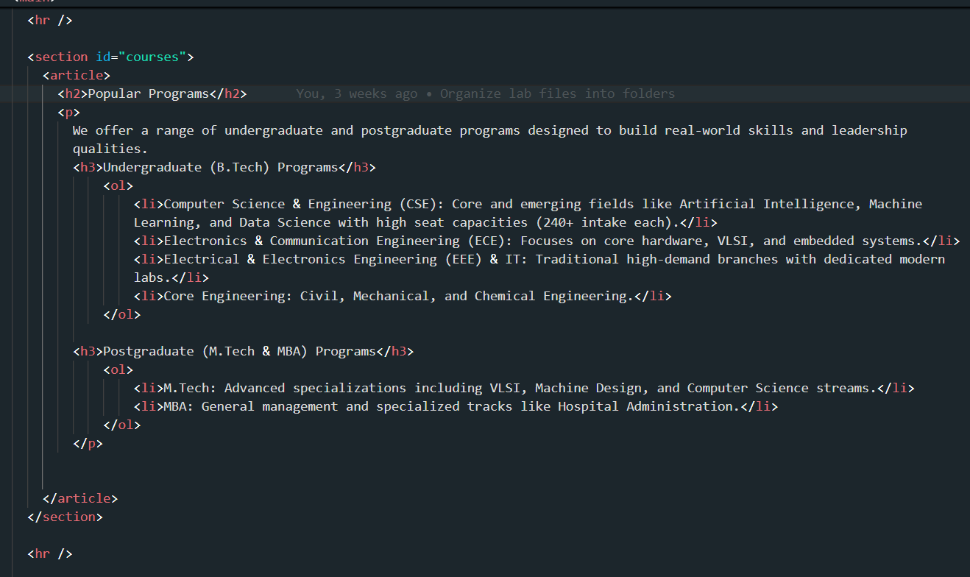
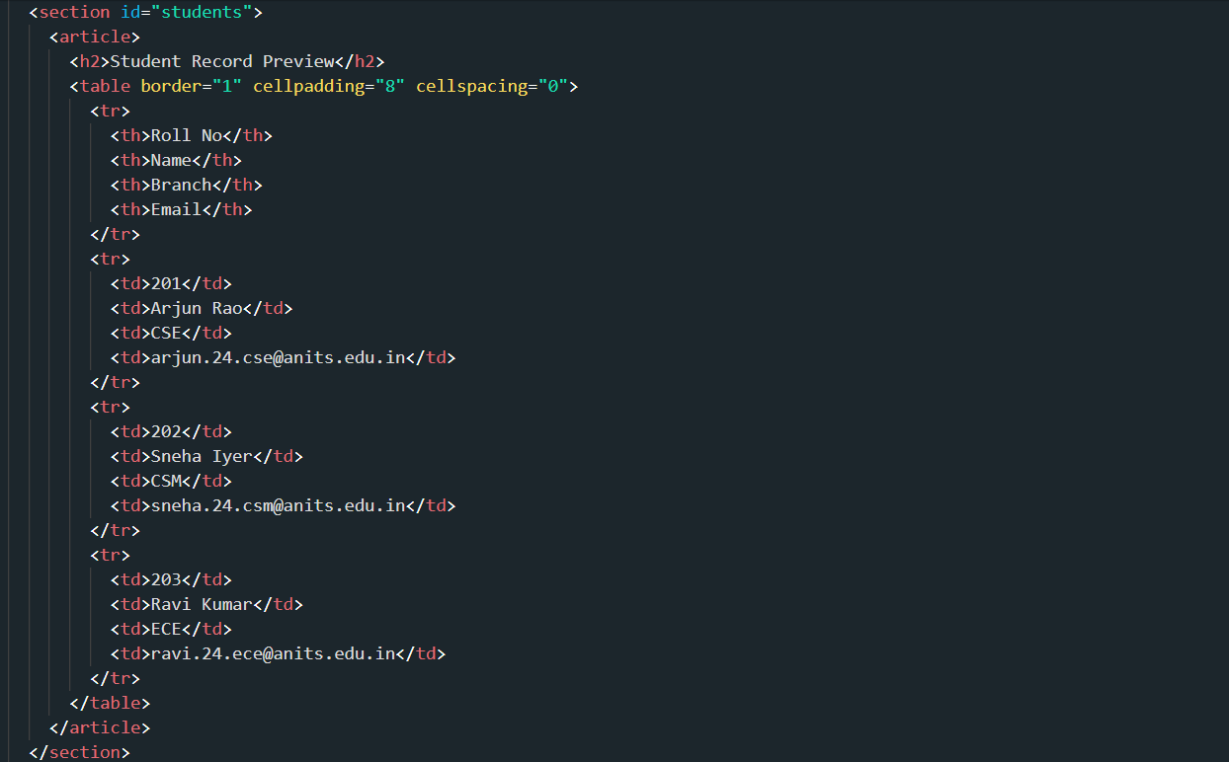

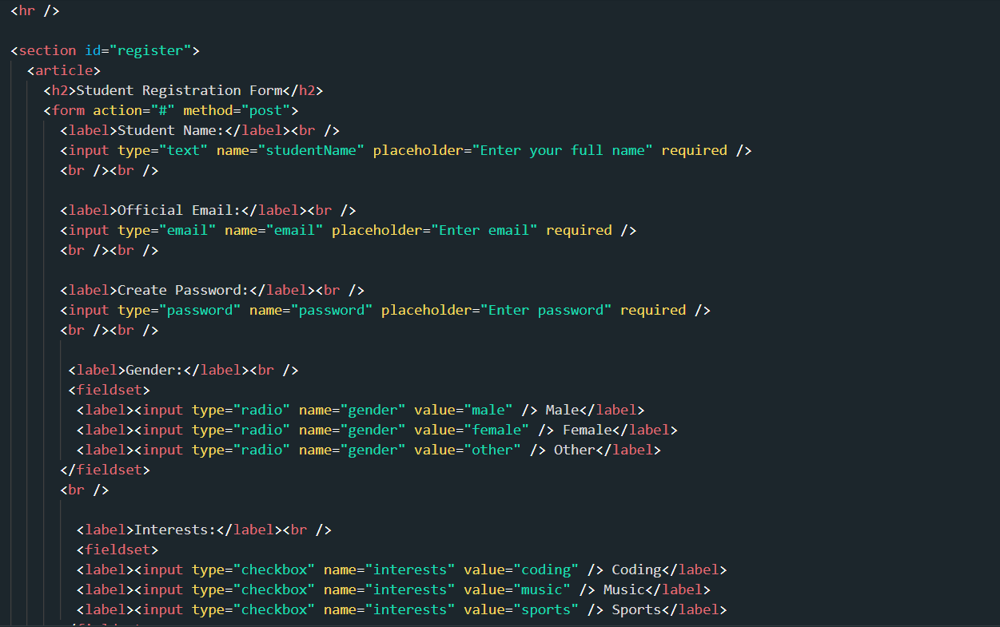
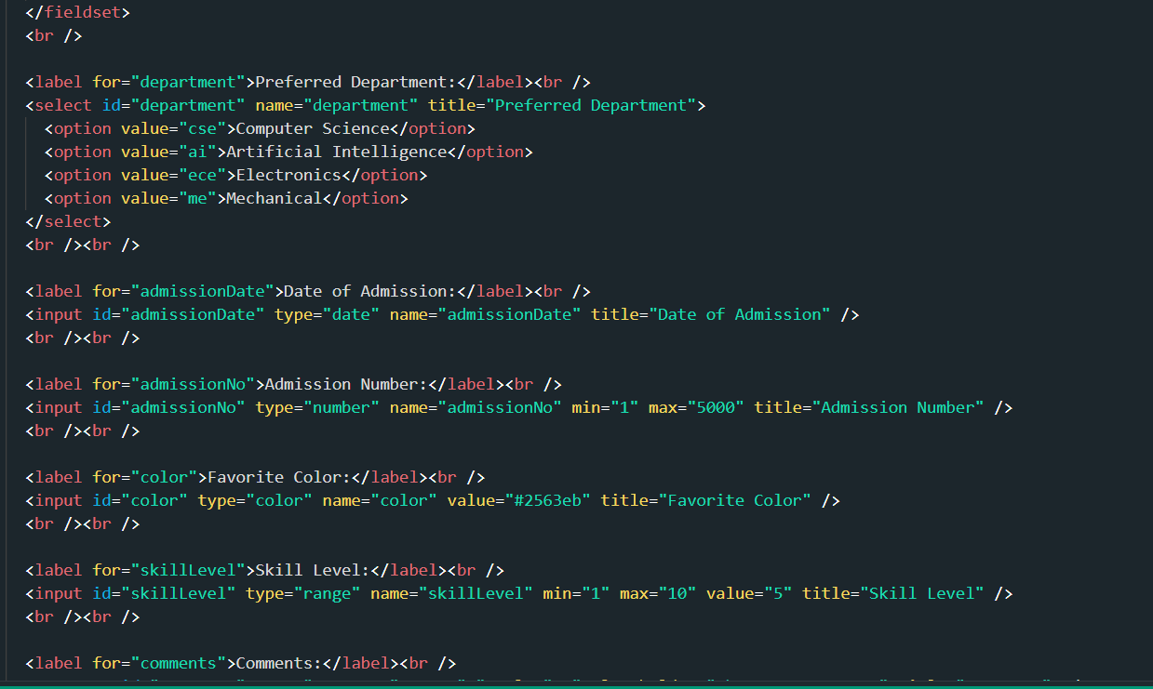

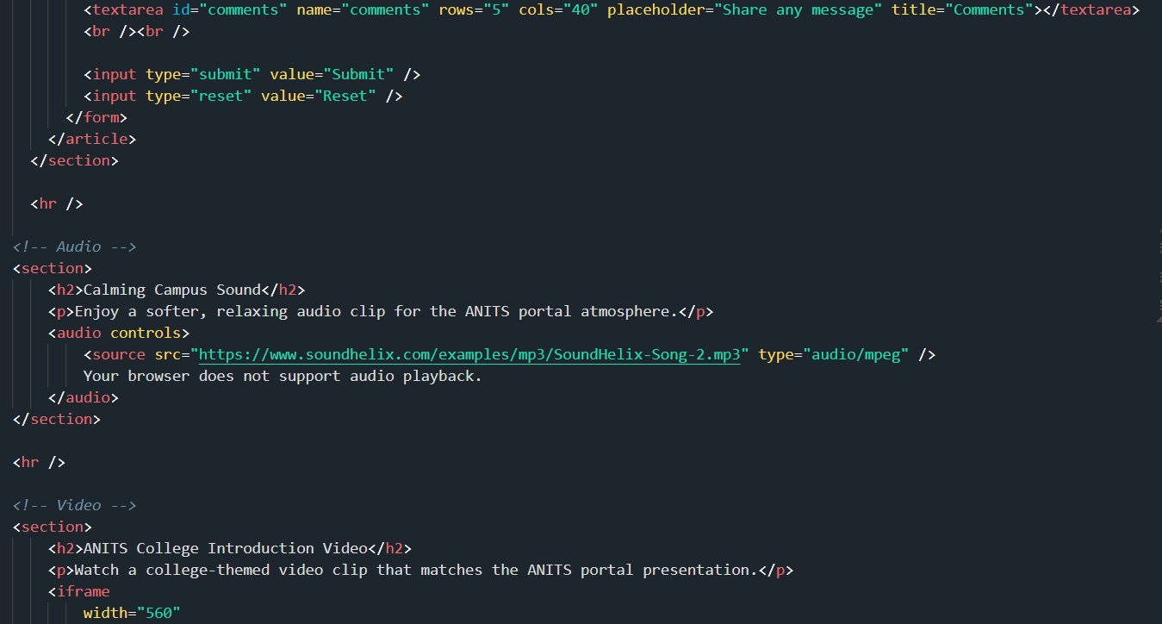
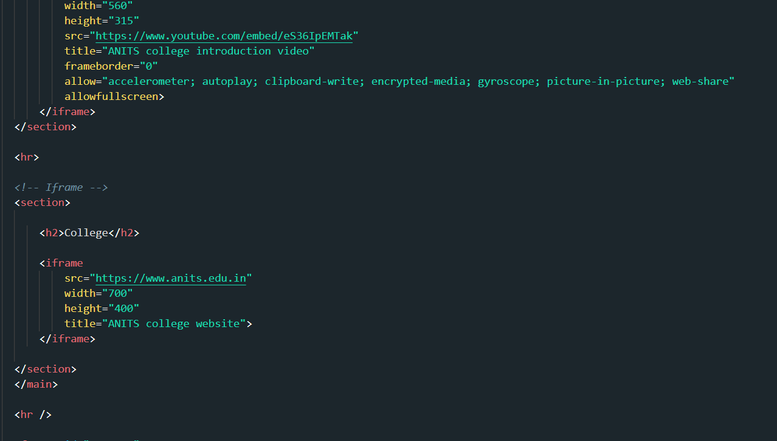

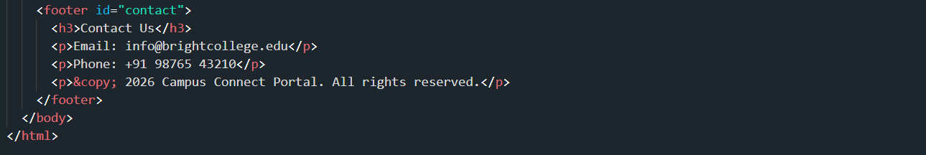

CODE EXPLANATION
HTML Element / Feature | Purpose
HTML5 DOCTYPE | Declares that the document uses HTML5.
head / title | Defines document metadata and the browser page title.
header | Contains the college logo, heading, and introductory text.
nav / a | Provides navigation links to Google, the college website, and page sections.
section / article | Organizes related college information into meaningful content blocks.
strong / em / u | Apply bold, italic, and underline formatting.
ol / ul / li | Create ordered and unordered lists.
table / tr / th / td | Create the student details table.
form / input | Collect student registration information.
radio / checkbox | Allow single-choice gender selection and multiple hobby selections.
select / option | Provides the preferred department dropdown.
textarea | Accepts longer comments or messages.
audio / iframe | Embeds audio and external webpage/video content.
footer | Displays contact information and copyright information.

TEST CASES AND EXECUTION DATA
Test Case | Verification | Expected Result | Observed Result | Status
TC-01 | Page loading | College portal page is displayed | Portal page displayed | Pass
TC-02 | Navigation | Navigation links are visible | Links visible | Pass
TC-03 | Student table | Roll No, Name, Branch and Email are displayed | Student table displayed | Pass
TC-04 | Registration form | Required form controls are displayed | Form controls displayed | Pass
TC-05 | HTML5 features | Audio, video and iframe content are visible | Audio/video/iframe visible | Pass

OUTPUT
The following are the actual browser output screenshots supplied for this task.
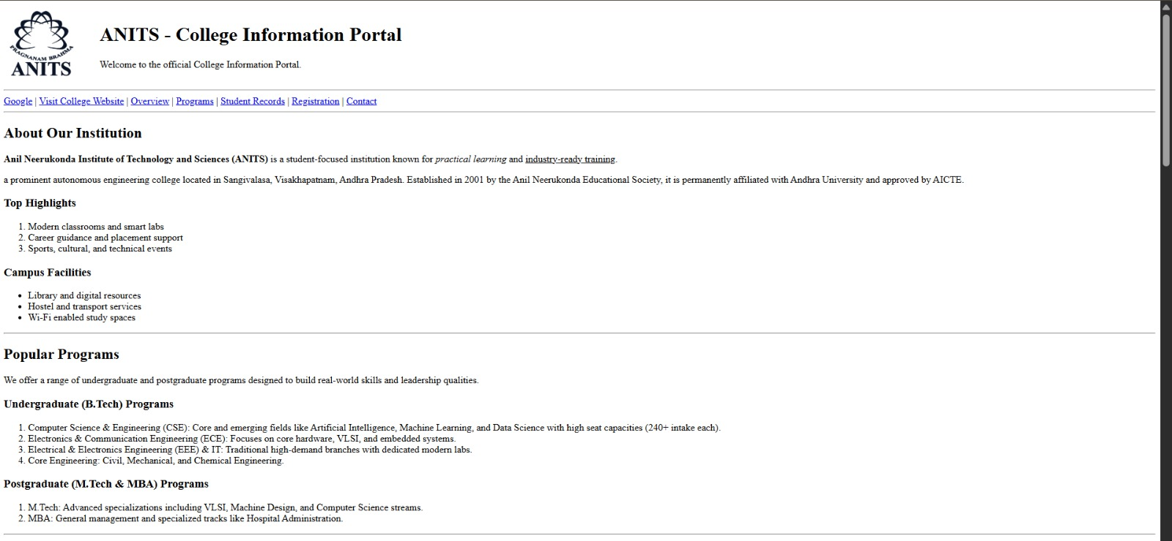


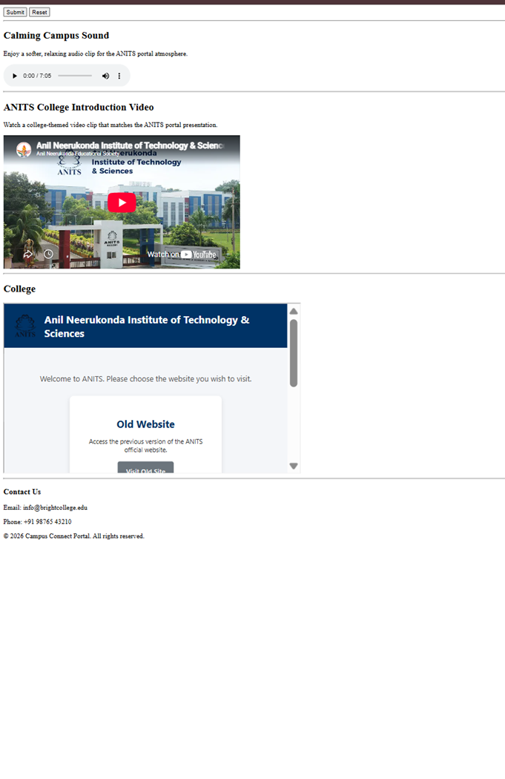

RESULT
Thus, the College Information Portal was successfully developed using HTML and HTML5. The webpage demonstrates basic HTML structure, text formatting, hyperlinks, lists, tables, images, a student registration form, semantic elements, HTML5 input controls, multimedia, and iframe embedding. The supplied browser screenshots verify the implemented features.

